Why are they called ‘forever chemicals,’ and other things to know about PFAS
By Dharna Noor Globe Staff,Updated July 7, 2022, 3:12 p.m.
11
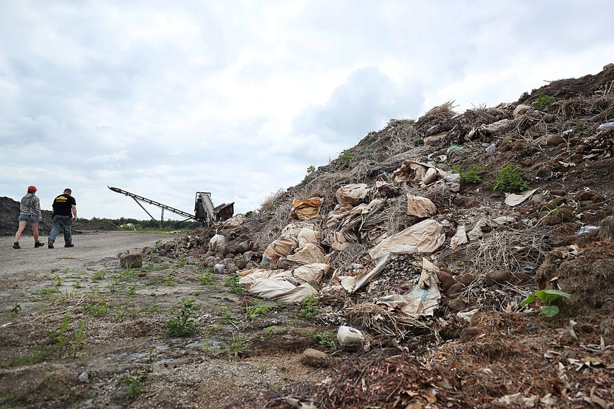Some of the composting piles at Massachusetts Natural Fertilizer, a composting company in Westminster, Massachusetts Natural Fertilizer linked to the contamination of drinking water with PFAS.Suzanne Kreiter/Globe Staff
Residents of rural Central Massachusetts were shocked to learn that a composting facility likely spread toxic “forever chemicals” known as PFAS into their drinking water, according to state officials.
They’re not alone. The state has identified dangerous levels of the compounds in 84 community water systems across the Commonwealth.
The chemicals have been linked to a slew of health problems, even in tiny quantities.
Here’s what you need to know about PFAS.
Related: When organic is toxic: How a composting facility likely spread massive amounts of ‘forever chemicals’ across one town in Massachusetts

What are PFAS?
The term PFAS refers to a class of man-made per- and polyfluoroalkyl compounds that have been around since the 1940s. Since they resist heat, oil, stains, grease, and water, manufacturers use them in everything from cosmetics and cookware to yoga pants and firefighting foam. They’re also found in construction materials and at airports and military installations.
“PFAS is virtually everywhere,” said Carol Gregory, senior vice president of communications and marketing at Boston-based Conservation Law Foundation.
PFAS earned the alarming nickname “forever chemicals” because they don’t break down easily in the environment. Because of their chemical makeup, they can stay intact for thousands of years.
“When it is dumped, it stays there,” said Kyla Bennett, director of Public Employees for Environmental Responsibility in New England.
That’s a huge problem for human health, because PFAS are highly toxic. Scientists have linked them to high cholesterol, hormone disruption, immune deficiency, and several cancers.
Even mind-bogglingly small quantities of the compounds are dangerous, compared to many other toxic substances. According to the Environmental Protection Agency, drinking water with arsenic concentrations of more than 10 parts per billion is unsafe. But last month, when the agency announced new drinking water advisories for the four most-notorious forms of PFAS, they measured unsafe concentrations of the compounds in parts per quadrillion.

How do PFAS spread?
Because of their persistence and widespread use, PFAS are ubiquitous.
“There are already 2,854 locations in the United States where there are known contamination sources,” said Judith Enck, former Environmental Protection Agency regional administrator and founder of advocacy group Beyond Plastics.
One 2020 study found PFAS in the bloodstreams of 99 percent of people tested.
The compounds can spread through the air or by ingesting contaminated food. But the “predominant” form of exposure is through drinking water, said Enck.
PFAS has been found in the drinking water of 80 million Americans, and Massachusetts is no exception. A 2021 Sierra Club analysis of statewide public water systems estimated that 70 percent of communities have detectable levels of the six most-dangerous PFAS chemicals in their ground and surface water.
Related: More communities are finding toxic chemicals in their drinking water
Since they’re so common, there are endless routes for PFAS to pollute, including through runoff from industrial sites, farms, and military bases. In New England, firefighting foam manufacturers, leaking landfills, artificial turf fields, pesticides, and plastic plants have all been identified as sources.

How do I avoid this stuff?
There are steps you can take to limit your exposure. A major one: having your water tested.
To do so, you can check out a list of certified laboratories on the Department of Environmental Protection’s website. But know that testing will come at a cost.
The state previously offered free testing for Massachusetts communities who use wells, but it is not currently accepting applications for the program, according to its website. Department of Environmental Protection officials were not immediately available to offer more details about whether the program will be reinstated.
Enck, the former Environmental Protection Agency regional administrator, who lives in upstate New York, paid $350 to have her well tested.
“It’s expensive,” she said. “$350 is out of reach for a lot of people.”
If you suspect — or confirm — that your water is polluted, you can purchase a certified filter.
You may also want to try to stop purchasing contaminated products. Fish, dairy, and meat often contain PFAS, said Bennett, and when it comes to produce, organic fruits and vegetables are generally less likely to be tainted.
Fast food is also often wrapped in grease-repelling paper made with the chemicals, said Enck.
For more information on which products contain PFAS, she recommended browsing resources from the nonprofit Environmental Working Group.
But since PFAS are all around us, avoiding them is no easy task.
“You have to ask manufacturers and sort through their greenwashing,” Bennett said, noting that sometimes companies will note that their products don’t include the most common forms of PFAS but say nothing about the other thousands of compounds.

What about compost?
In Westminster, state officials identified a surprising culprit of PFAS pollution: a composting facility, Mass Natural.
Bennett said a likely source of that contamination is paper waste, since “a lot of coated paper goods and inks contain PFAS.”
The paper company Seaman has trucked thousands of tons of waste materials from their mills to Mass Natural over the years. But company officials told the Globe that the firm tested their waste and found no evidence of “high concentrations” of PFAS.
“We are confident that we are not the source of the PFAS chemicals, because of the types of paper products we manufacture,” Ken Winterhalter, Seaman’s CEO, said in a statement.
Matter recycled from wastewater treatment plants and food scraps from farms using contaminated fertilizer can also contaminate compost with PFAS, Bennett added.
Federal regulators and independent researchers have located PFAS in compost before. But Gregory said it’s unlikely that Massachusetts facilities are testing bagged compost for contamination.
“There is no comprehensive lab test developed yet to determine the amounts of PFAS in compost,” he said. “Various labs have test components that can provide information, though they are often costly.”
Don’t worry — this doesn’t mean you have to stop composting.
Related: Mayor Wu announces new citywide composting program
Kirstie Pecci, director of the zero-waste project at the Conservation Law Foundation, told the Globe that municipal composting programs are safer than industrial ones, since they’re generally untainted by sewage materials.
For that reason, home composting is also a good option, said Bennett.
As another precaution, she said, stick to organic produce, which should be untouched by PFAS-contaminated fertilizer.
Mass Natural also sells loam, potting soil, and mulch made with compost. Since it seems to be contaminated, that distribution needs to stop, said Clint Richmond, toxics policy lead at the Massachusetts Sierra Club.
“We shouldn’t be using that for anything having to do with farming or food, or even parks — places where people might be exposed,” he said.

Thinking bigger
Individual action alone can’t stop the PFAS problem, advocates say. Governments and companies need to do more.
“The way the states and EPA have been handling PFAS is one of the greatest regulatory failures in environmental history,” said Enck. “The agencies have known about the problems with PFAS for decades but they’ve just really started getting serious about it in the last decade.”
Bennett said more limits on exposure would help.
She said that though the federal government issues health advisories for PFAS, it doesn’t currently regulate them, but it should.
Massachusetts regulates six kinds of PFAS, but there are thousands of others.
“EPA and the states need to regulate PFAS as a class of chemicals, not one by one,” said Enck. In April, a state task force recommended doing so.
Enck said the federal government should also phase out the production and use of the chemicals, and allocate more resources to remediation. And she said that state and federal officials should also be more proactive about testing water near likely polluters.
“Agencies will sometimes say, ‘PFAS is everywhere! We can’t necessarily find the source.’ But that is a very intellectually lazy, unacceptable posture for a regulatory agency to take,” she said. “If you don’t look for the problem, you’re not going to find it.”

